**Maintenance Automation Notification Application To Asset Maintenance Personnel**

**Muhammad Farid Alwan Assyifa1), Roni Andarsyah2), Noviana Riza3)**

Applied Bachelor Program of Informatics Engineering, Politeknik Pos Indonesia

Sariasih Street No. 54, Sukasari, Bandung 40151, Indonesia

Telp. +6222-2009562, 2009570 Fax. +6222-2011099

1)[muhammadfaridalwana@gmail.com](mailto:muhammadfaridalwana@gmail.com), 2)[roniandarsyah@poltekpos.ac.id](mailto:roniandarsyah@poltekpos.ac.id), 3)novianarizappi@gmail.com

***Abstract***

*PT Pertamina is a state-owned company engaged in the field of energy, especially oil and gas. PT Pertamina has various directorates, one of which is the Directorate of Upstream. The Directorate of Upstream has the task of managing all the data contained in the Upstream. Petrotechnical Upstream & Application is one of the functions of the Directorate of Upstream which has the task of managing the administration of data relating to Upstream and where the data management is located in the Pertamina Upstream Data Center, in other words, PUDC is a repository for all upstream oil and gas activity data both primary data belonging to Pertamina and secondary data from various research publications and studies of other institutions based on upstream oil and gas activities and other allied science.*

*To help support the management of Upstream Data, a good asset maintenance management system is needed. With good asset maintenance management, it will help employee performance in managing data. Asset maintenance is needed to maintain assets in good condition. Maintenance scheduling done manually allows employees to be late in doing maintenance because employees must check the schedule regularly and also there are no reminders to employees who are responsible for maintaining assets following the maintenance schedule that has been made.*

*From the problems described above, we need an automation notification maintenance scheduling application for employees using Rapid Application Development development methods where this application provides reminder functions to employees in the form of SMS, WhatsApp and Email, so using this application makes it easier for employees to carry out maintenance under pre-planned schedule and no need to worry too late to carry out maintenance due to the notification reminder.*

***Keywords:*** *Pertamina Upstream Data Center, Maintenance, Notification, Automation.*

**1. Introduction**

PT. Pertamina (Persero) is one of the state-owned enterprises (BUMN) that is engaged in the supply of oil and gas. Pertamina's activities in the field of energy business are divided into the upstream and downstream sectors and supported by the activities of subsidiaries [1]. Upstream Technical Center is part of the upstream Directorate, the task of Upstream Technical Center to fulfill the demand for technical assistance in Pertamina's environment in the form of Task Force specialist, study and Problem solving, centralization of data and software applications, simulation & Modeling, workshop & Training and other work in line with the competency of specialists in Upstream Technical Center. Besides, related to the development of Upstream Technical Center (UTC) data has Pertamina Upstream Data Center (PUDC) located in the Sunday market area, South Jakarta. PUDC is the place to store all upstream oil and gas activities data of Pertamina's primary data as well as secondary data derived from various publications of research results and studies of other institutions based on upstream oil and gas activities.

To support the operation of the activities in the Pertamina Upstream Data Center This is the need for good assets. So the maintenance or maintenance of this asset is very important [2]. Delay in maintenance or maintenance of this asset will inhibit the activities in the Pertamina Upstream Data Center, despite the planning scheduling this maintenance but sometimes this implementation is not under the planning Due to the absence of a reminder to officers who do maintenance on the assets [3].

With the problems that have been discussed in the explanation above, it is necessary a solution that can overcome the problem. So it raises an idea to create "Maintenance Automation notification application to Asset Maintenance officer" which will give a reminder to maintenance officers in the form of Email, WhatsApp messages and SMS notifications from the application that will be Wake up later in the development of this application authors using the Rapid Application Development method [4].

**2. Related Work**

Maintenance is one activity to maintain or preserve an asset that the asset in good condition, so that when the asset is required or used then that asset can function properly. Good maintenance is the maintenance of which has a regular schedule [5]. With their regular schedule within a certain period then it will make this maintenance activity function more optimally and maintenance activities conducted by officers who have been designated to be responsible for the type of assets there. Officers can see the maintenance schedule has been made following the schedule of assets under its responsibility. Therefore, the authors build applications that are useful to give notification to maintenance personnel to perform maintenance [6].

By using automated reminders on this application then makes the officer need not worry about the delay to perform maintenance on the assets that have been scheduled because the clerk will get a reminder in the form of SMS notifications, WhatsApp and Email, fill in the notification [7].

The advantages of this application are the automation feature reminder notification to maintenance personnel in Pertamina Upstream Data Center with their automation automatically checks the schedule then make officers do not need to manually check the schedule and biased focus to carry out other activities.

**3. Research Method**

In this research, the author will implement the Rapid Application Development method in the Maintenance Automation notification application to the maintainers using the PHP programming language supported by the CodeIgniter framework as well as Using a MySQL Web service and database. The plot in the Rapid Application Development method is first, the author gathers all the needs in the author's sense Mengidentifiasi The problem and determines the research objectives. Second build prototype in building this prototype two types are building business processes and building design designs. All three authors do a prototype evaluation in the evaluation of this prototype authors check if it is under the design that was previously made in the second stage if it is not yet appropriate then the author will again be able to make a second The appropriate design so that it will continue to be discovered fourth. This phase of the author is implementing a maintenance Automation notification application to the maintenance personnel. Once the application is finished then the author is obliged to test if the application is worth what it hasn't been. After that the author can conclude the application that has been created by this author. For more details the flow of this Rapid Application Development method is on the next page.



Figure 1. Metode Rapid Application Development

**4. Results and Analysis**

The analysis is also the beginning in the construction of an information system, from the decomposition of a complete information system into its component parts intended to identify and evaluate all problems that arise, so that improvements can be proposed that can build. implementation of information will not run well without an analysis of the information to be built and used.

**4.1. Analysis of current system**

Maintenance is one activity to maintain or preserve an asset that the asset in good condition, so that when the asset is required or used then that asset can function properly. To maximize doing this maintenance requires the maintenance schedule to remind them. Making the maintenance schedule in this PUDC still made manually so that the officer should check back every month so that the workers allow not too late to do the maintenance schedule and after maintenance officers also generate reports manually what to do when maintenance. Therefore we need a computerized system for this process to make it easier to perform maintenance officers in PUDC (Pertamina Upstream Data Center).

**4.2. Analysis of the System to be Built**

The requirement analysis here is a flow map analysis of the system to be built including login procedures, Schedule Maintenance procedures, payment procedures, and Asset Management procedures. The Flowmap will be constructed as follows:

A. Analysis System to be Built in Preventive Maintenance

First admin login, after login, the system will display a page admin (home) in the admin page, there are three menus is a menu asset management, employee management, and maintenance schedule and every menu there is a separate process. In the asset management, admin can add assets, edit asset and remove the assets, in the menu of employee management admin can add the employee not only added in the menu of employee management admin can edit and delete and activate user account while the menu schedule maintenance admins to schedule maintenance where the system will read the data that has been fed by the admin and will be at the show by a maintenance officer. The first officer then the login page will be displayed officer (home) in the pages of this officer.

B. Analysis System to be Built in the Login procedure

In this login procedure, the first user opens the Preventive Maintenance page then input username and password the system will automatically read the input and the system will check if the username and password is valid what is not in the database, If the username and password are valid according to the database then the system will automatically redirect to the home page under the right access, if the username and password is not valid then the system will ask the user to input the username and password again.

C. Analysis System to be Built in Schedule Maintenance

After admin menu Schedule Maintenance then Admin will be on display page, where the admin can input the type that will be in maintenance after the admin chooses the type that will be in maintenance than the admin then prefer on the date and month later Save the data.

D. Analysis System to be Built in on Asset Management

Admins can input assets and choose the type of asset and also choose the asset will be activated what is not and the Admin can also edit the existing asset data, then admins can delete assets that are not needed.

**4.3. Results and Discussion**

Implementation steps are the most important thing that must be implemented to get the most out of the built applications. The implementation of this application is applied as an application that can be accessed by officers or admins. Based on the design of the system compiled, the programming language used is PHP supported by the framework CodeIgniter and using the MySql database. In MySql, the database creation facility is available optimally to facilitate the preparation of data from the table. With this app created all the problem identification and planned objectives have been achieved.

A. Login Page

In this form, if the user wants to log into the application must be logged on this page.

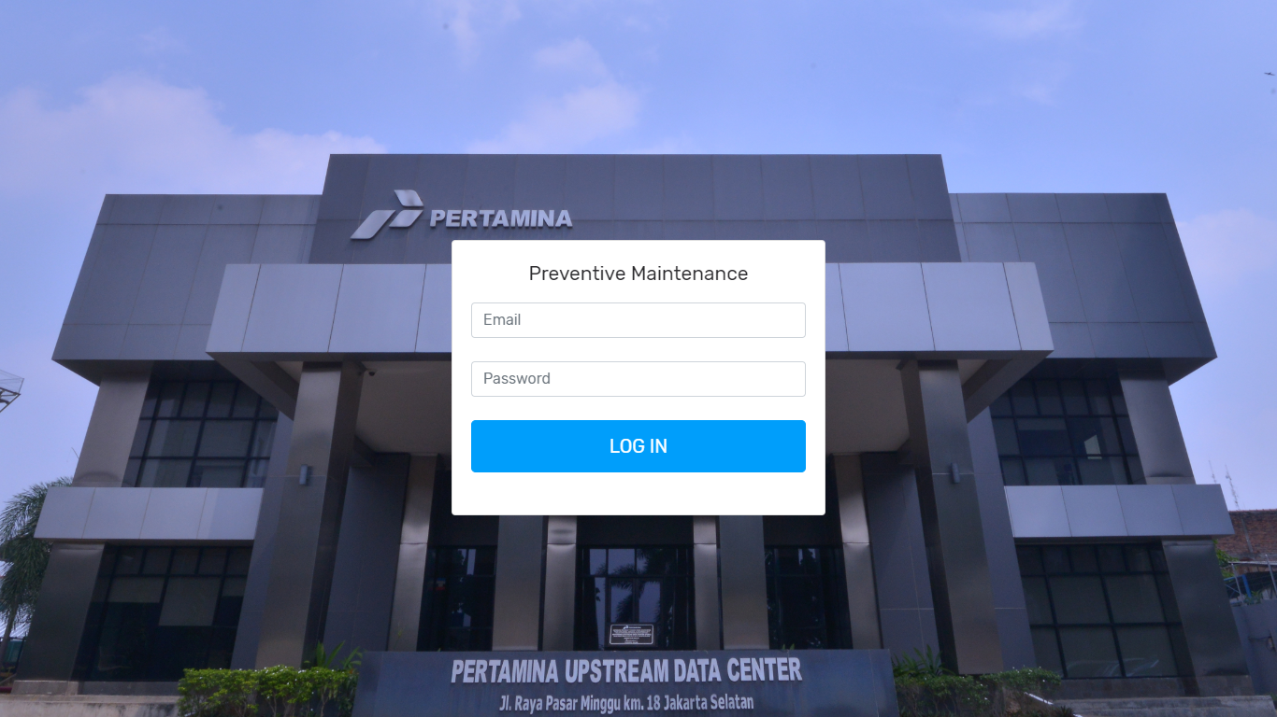

Figure 2. Login Page

B. Admin page

When the user with access rights institutions have successfully logged it will appear a menu to set the Maintenance Schedule, Employee, Asset.

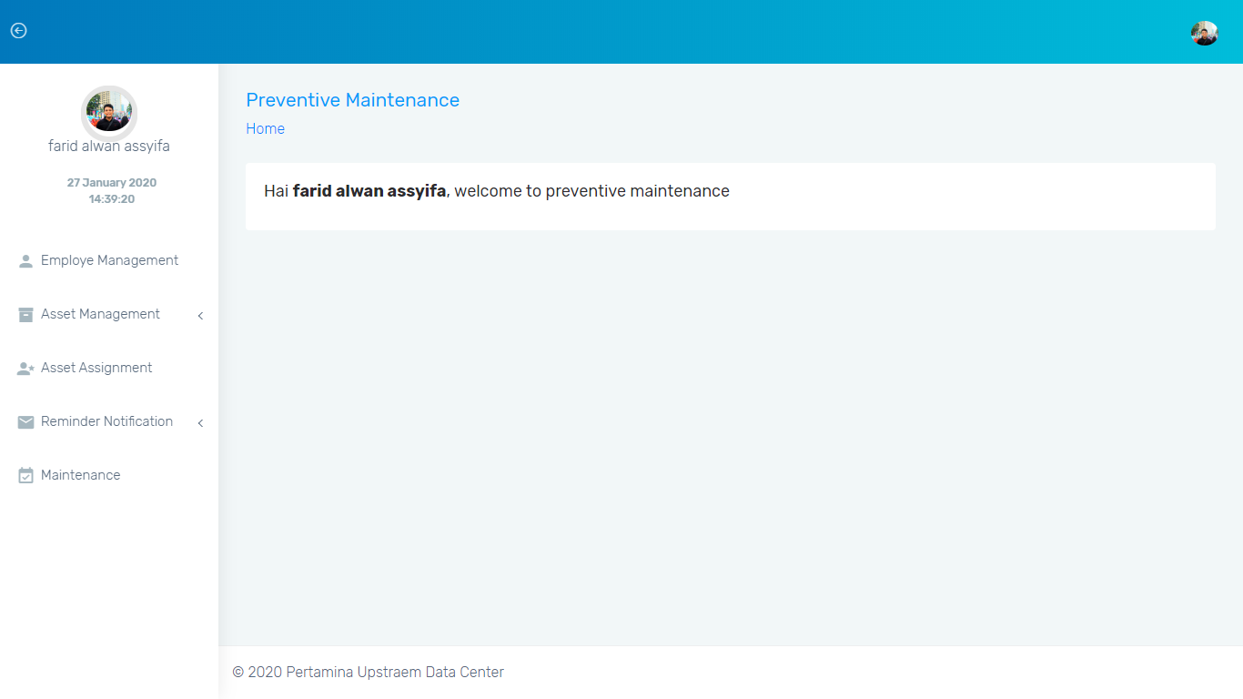

Figure 3. Admin Page

C. Officers page

When the user with access rights institutions have successfully logged it will appear to set the Report Maintenance menu.

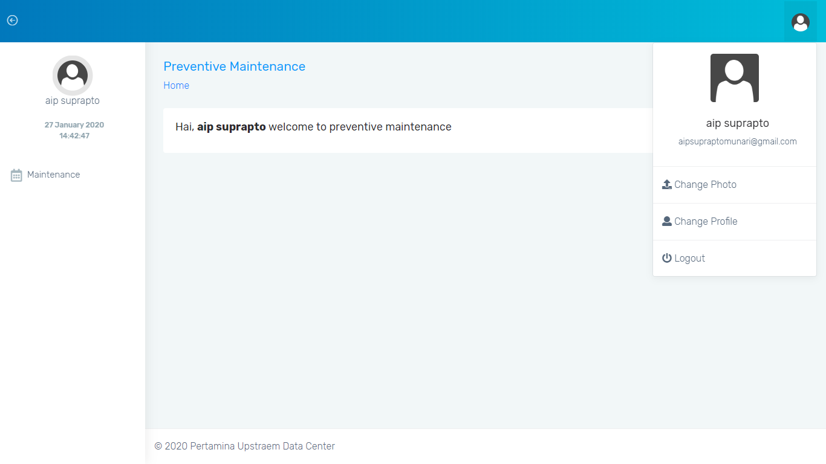

Figure 4. Officer Page

**5. Conclusion**

After designing, implementation and testing of the Pertamina Upstream Data Center Maintenance Automation Notification application (case study: PT. Pertamina (Persero)) using the Rapid Application Development method, can answer the problems are:

• With the application of asset maintenance automation notifications to employees, the application can help in providing reminders to the officers and the application has the feature of managing the asset maintenance schedule in PUDC.

• Officers get notification reminders in realtime in the form of SMS, WhatsApp and Email to perform maintenance at PUDC assist in alerting assets in PUDC, making it easier for staff to perform maintenance following the schedule that has been Planned.

**Acknowledgement**

Thanks to Allah SWT, parents who have given their Prayers and support, all D4 Informatics Engineering lecturers at the Pos Indonesia Polytechnic, especially our supervisors and examiners, are Mr. Roni Andarsyah, S.T., M.Kom and Mrs. Noviana Riza S.Si., M.T. for his advice and assistance in making this application, my friend who has helped develop this application, as well as unnamed parties who have helped and provided support.

**References**

[1] I. S. Utami, *Saragih, Irma Sri Utami*. 2019.

[2] L. Haryono and A. Susanty, “Penerapan Total Productive Maintenance Dengan Pendekatan Overall Equipment Effectiveness ( Oee ) Dan Penentuan Kebijakan Maintenance Pada Mesin Ring Frame Divisi Spinning I Di Pt Pisma Putra Textile,” *Ind. Eng. Dep. Fac. Eng. Diponegoro Univ. Jl. Prof. Soedarto, SH, Kampus Undip Tembalang, Semarang, Indones. 50275 Email *)* [*lilikharyo@gmail.com*](mailto:lilikharyo@gmail.com).

[3] T. M. A. Rahman, “Manajemen Perpustakaan Berbasis Sistem Otomasi,” *J. Isema Islam. Educ. Manag.*, vol. 3, no. 2, pp. 114–124, 2019.

[4] S. Hartati, N. A. Kristiana Dewi, D. Puastuti, M. Muslihudin, and N. Setio Budi, “Sistem Aplikasi EDUCHAT STMIK PRINGSEWU Berbasis ANDROID Sebagai Media Komunikasi dan Informasi,” *J. Nas. Teknol. dan Sist. Inf.*, vol. 3, no. 1, pp. 143–152, 2017.

[5] JAYALAKSHMI, A., et al. MOBILE APP 2017: MAINTENANCE OF CONSTRUCTION SITE DETAILS THROUGH ELECTRONIC SIGNATURE. *International Journal for Research in Science Engineering & Technology*, 2017, 4.5: 28-33.

[6] RAMSARI, Nopi; RIFALDI, Achmad. RANCANG BANGUN APLIKASI PENJADWALAN KEGIATAN AKADEMIK DISERTAI SISTEM REMINDER BERBASIS RESPONSIVE WEB DESIGN. *Jurnal Teknologi Informasi dan Komunikasi*, 2019, 8.1.

[7] SWATHIJA, R., et al. Alert Me An Android Application For Time Table Reminder System.